How to deal with the CSPro programs when the basket change

When all the necessary work has been done in the powerbuilder system, there are only two files that need to be changed in the CSPro system.

The files described here are to be found in the CPI file system in the folder CPI\lookup on the computer you are currently working on. Please remember that *they have to be copied to the server to take effect!*

# The “file prodNumber_Coicop3.txt”

This file is for matching the product IDs in powerbuilder with the 3-digits COICOP number. As can be seen below, it is a tab separated file with the columns

Product ID from – Product ID to – Coicop code – Description

Edit the file to match the current situation.

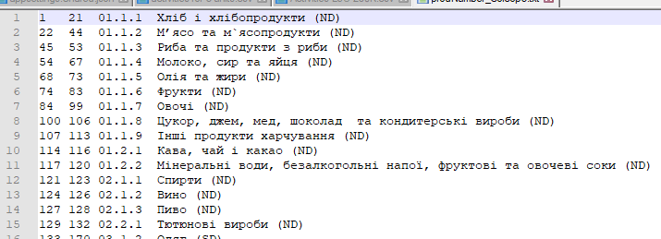

After editing the file, verify that the charset is correctly set to “cyrrillic – windows-1251” and “UTF-8-BOM” as must be done for all text files in the system.

# The file Coicop_lvl3.csdb

This file is in the CSPro database format and hence not that easy to change, hence the functionality to do this is added to the Admin program to be used in the local offices and by the administrators of the main office.

To get to the stage where you can edit the file, start up the admin program, log in as CPI_admin and choose the last option “99 edit coicop file” in the dropdown to choose oblast.

The following program will open. In the left pane are all the current codes listed:

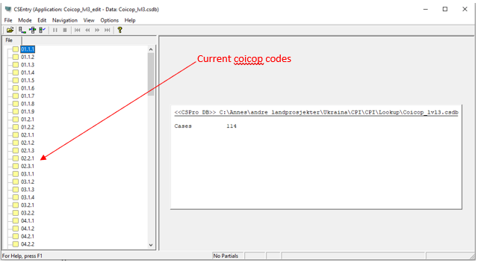

Zooming in to see the icons on the tool bar:



Explanation of the icons:

*  Add new coicop code
*  Modify existing (ie: Change description of code)
* To delete a code: right click and choose delete
* Stop doing whatever you’re doing



Hence, clicking on the different icons you can change, add or delete the Coicop codes. When adding or modifying: after entering/changing the last field – the description field, press tab or enter to continue. This will pop up this window:

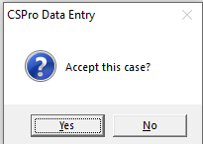

Choose “yes” and the record is changed.

NB: The new file is to be found in the Lookup folder *on the computer you are working on*:

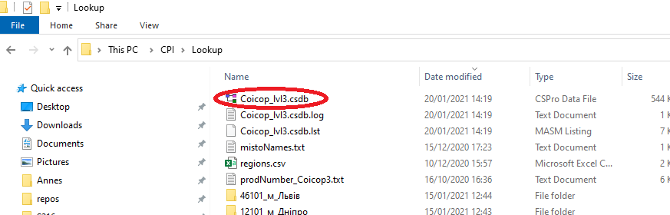

Copy the file to the lookup folder on the server.

# The file prodnumber_Monitor.txt

This file is just the list of files for the monitoring survey, tab separated. It must be placed in CPI/lookup/prodnumber_monitor.txt, and this is the structure:

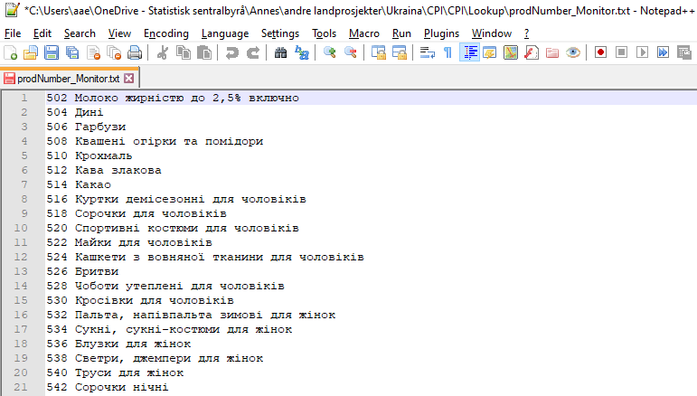

After editing the file, verify that the charset is correctly set to “cyrrillic – windows-1251” and “UTF-8-BOM” as must be done for all text files in the system.